Faculty Position in Tumor Immunology at Dartmouth

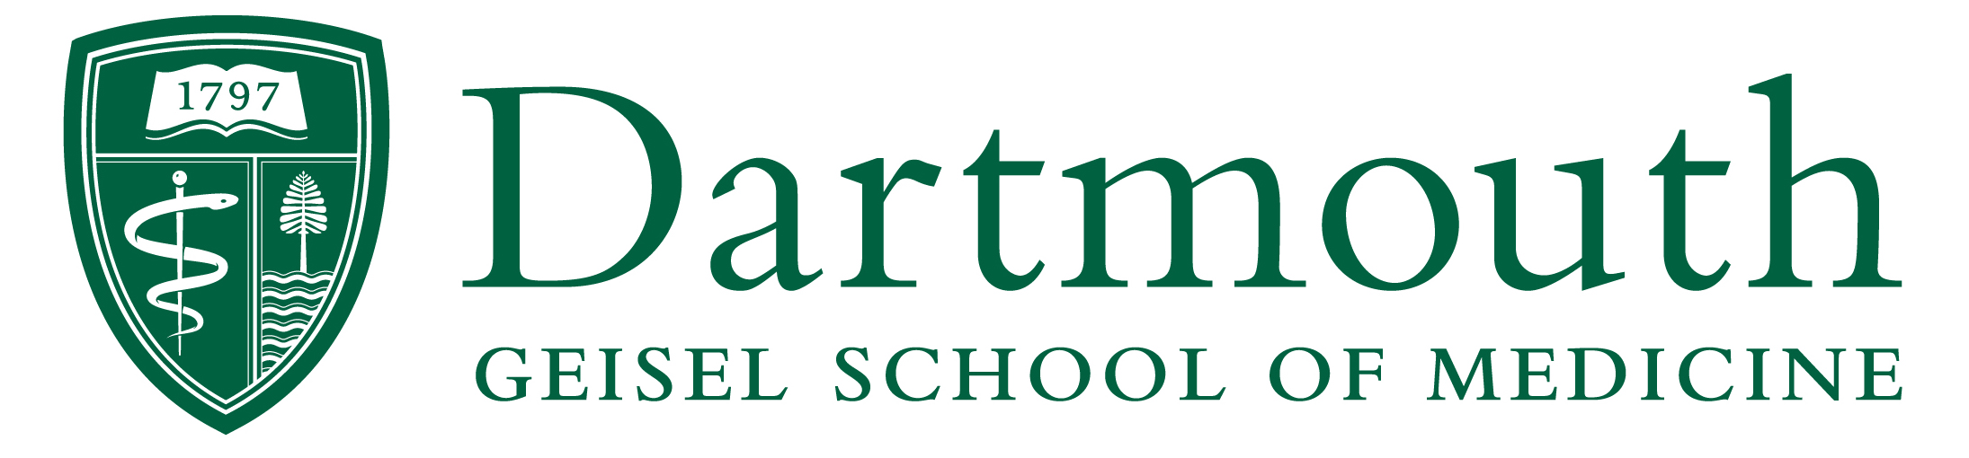

The Department of Microbiology and Immunology and Norris Cotton Cancer Center (NCCC) at the Geisel School of Medicine at Dartmouth invite applications for a tenure-track faculty position to join our highly collaborative NCI-funded Immunology and Cancer Immunotherapy Program. Appointment is planned at the Assistant Professor rank, however exceptional candidates at more senior ranks may also be considered.

We seek an outstanding and collaborative individual to develop an innovative research program in Cancer Immunology. A generous start-up package and access to state-of-the-art research facilities will be provided. Existing research strengths at Dartmouth include checkpoint inhibitor therapy, CAR T cell therapy, cancer vaccines, T cell memory, and tumor microenvironment. NCCC, one of 49 NCI-designated Comprehensive Cancer Centers, offers a dynamic and interactive environment, with a commitment to research excellence commensurate with Dartmouth’s status as an R1: Doctoral University – Highest Research Activity in the Carnegie Classification.

The successful candidate will have access to thriving multidisciplinary graduate programs through the Guarini School of Graduate and Advanced Studies (e.g., Program in Molecular and Cellular Biology, Program in Quantitative Biomedical Sciences, and the Program in Experimental & Molecular Medicine). In addition to NCCC, faculty members in the Microbiology & Immunology Department benefit from highly collaborative and collegial interactions across Dartmouth, inclusive of other departments at Geisel, the School of Arts & Sciences, and the Thayer School of Engineering. Candidates may also benefit from interactions with three current NIH Centers of Biomedical Research Excellence (COBREs), Dartmouth’s supercomputing networks (e.g., Discovery); and Dartmouth's Clinical and Translational Science Institute (SYNERGY). Successful candidates are expected to develop a robust research program and excel in graduate student teaching.

Applicants for this position should possess a Ph.D., M.D., or M.D/Ph.D. degree, postdoctoral research experience, and a track record of research accomplishments in the field of tumor immunology. Independent grant funding is desirable, but not required at the level of Assistant Professor.

Application materials including a cover letter, curriculum vitae, representative publications, a statement of research interest (not to exceed 3 pages) and three letters of recommendation, should be uploaded to: http://apply.interfolio.com/61454 Application review will begin on April 1, 2019 and continue until the position is filled.
Dartmouth and the NCCC are located in the picturesque upper Connecticut river valley on the New Hampshire/Vermont Border, and is surrounded by a vibrant academic and professional community offering excellent schools, lively arts, and an unmatched quality of life, in a beautiful rural setting.
Dartmouth-Hitchcock Medical Center and the Geisel School of Medicine at Dartmouth are equal opportunity/affirmative action employers with a strong commitment to diversity and inclusion. We prohibit discrimination on the basis of race, color, religion, sex, age, national origin, sexual orientation, gender identity or expression, disability, veteran status, marital status, or any other legally protected status. Applications by members of all underrepresented groups are strongly encouraged.

